Case 4-Eur-Italy-Roman-Bronze bust-Female-200 CE

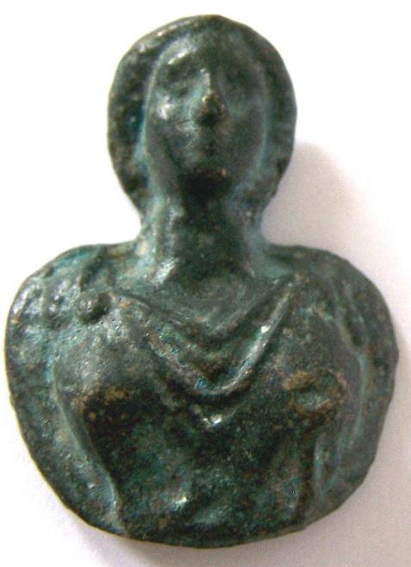

Italy-Roman-Bronze bust-Female

Case no.: 4

Accession Number:

Formal Label: Roman-Bronze bust-Female

**Display Description: This individual wears a toga and a flower-shaped fibula which was in vogue during the 2nd -3rd centuries CE.**

**Roman bronze female busts like this one may have accompanied legionnaires in their various exploits to remind them of their loved ones at home.**

**LC Classification:**

Date or Time Horizon: 200 CE

Geographical Area: Rome

**Map:**

**GPS coordinates:**

Cultural Affiliation: Roman

Medium: bronze

Dimensions: H 4 cm, W 3 cm

Weight:

Condition:

Provenance:

**Discussion:**

**References:**

|  |
| --- |
| **Payment details** |
|  |
|  |
| **Shipping details** |
| **Ralph J Coffman Jr**  149 Atlantic Ave  Swampscott MA 01907-2427  United States |

Order details

|  |  |  |  |
| --- | --- | --- | --- |
| **Item title** | **Available actions** | **Shipping & handling (estimated delivery*)** | **Price** |

|  |  |  |
| --- | --- | --- |
| Seller: | [**Member id** antiquewd](http://myworld.ebay.com/antiquewd) ( [**Feedback Score Of** 1433](http://feedback.ebay.com/ws/eBayISAPI.dll?ViewFeedback&userid=antiquewd)) | [Contact seller](http://contact.ebay.com/ws/eBayISAPI.dll?ShowCoreAskSellerQuestion&frm=3998&iid=0&redirect=0&requested=antiquewd) |

|  |  |  |  |  |
| --- | --- | --- | --- | --- |
| **Order # 123464626018**  Paid on Oct-28-12 via PayPal | | | | |
|  |  | |  | | --- | |  | | |  |  | | --- | --- | | [Contact seller](http://contact.ebay.com/ws/eBayISAPI.dll?ShowCoreAskSellerQuestion&frm=3998&iid=360501193298&redirect=0&requested=antiquewd) |  | | |  |  |

[Roman style bronze face**- opens in a new window or tab**](http://cgi.ebay.com/ws/eBayISAPI.dll?ViewItem&item=360501217436)

**Item Id:**360501217436 - Price: US $76.00

Quantity:1

Having a problem with this purchase? [We can help](javascript:;)

|  |
| --- |
|  |
| |  |  | | --- | --- | | [Leave feedback](http://feedback.ebay.com/ws/eBayISAPI.dll?LeaveFeedbackShow&useridfrom=802-867&useridto=antiquewd&item=360501217436&transactid=0) |  | |

Shipped with item above

**Package 1 of 1**



Shipment details: [9410809699937262021869](javascript:;)

US $76.00